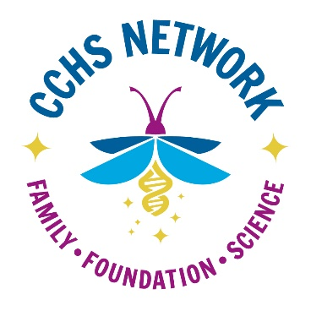 Clinical Reporting Form (to be completed by CCHS physician)

One of your patients, _______________________________ (patient’s name) is requesting from you clinical confirmation of their CCHS diagnosis so that the family can register with and join the CCHS Network, a non-profit 501(c)(3), tax-exempt organization registered in the United States to provide support, as well as education, for CCHS patients and families. Network membership provides the family opportunities to share in online (closed) Face Book discussions with other CCHS families from around the world. This forum is very useful in helping families address daily care issues and provides valuable community for the family and/or the older patient living with a rare diseases diagnosis. The Network also holds family conferences regularly where physicians and others meet, talk and generally educate about CCHS and current research and much more. Our website (www.cchsnetwork.org), open to all, also provides much information on all aspects of CCHS.
In the United States, Europe, and Asia there are two widely-used standards of CCHS for membership in the CCHS rare disease community. Patients/families seeking membership to the CCHS Network must provide evidence consistent with one of these definitions before their application is accepted.
- CCHS is diagnosed through genetic testing of the Phox2B gene.

- In extremely rare cases, a patient may be diagnosed clinically when the genetic test is negative. Your patient/family is asking for you to confirm a clinical CCHS diagnosis.

If current CCHS testing did not show a CCHS mutation, please confirm that the patient has been found to meet a clinical definition of CCHS as given below. We assume the physician knows CCHS well and/or cares for other CCHS patients and is familiar with CCHS lab testing. The vast majority of CCHS patients are diagnosed and seen at one of the recognized CCHS Centers around the world. We do retain the right to have this form reviewed by a CCHS Center, should questions remain. The patient/family has signed a medical information release form, which accompanies this letter, and is also filed with us.

Clinical criteria for a CCHS diagnosis include the presence of at least 3 of these 4 medical findings:
1. Chronic Respiratory Failure Characterized by:
CO2 Retention and/or
Hypoxia
2. Abnormality in central control of breathing
3. Lack of confirming differential diagnosis (diagnosis of exclusion method): i.e. metabolic, neuro-muscular, chronic lung disease, and obstructive airway disease is clearly ruled out as a cause of respiratory failure
4. Clinically confirmed dysautonomia

To confirm your diagnosis of clinical CCHS for _______________________ (patient’s name), please report to us in the space below which 3 of the 4 criteria above have been observed in this patient. Please check all the boxes that apply and include a brief statement, with supporting documents, of clinical observations for each criteria selected leading to your CCHS diagnosis in the patient. Thank You.

- Chronic Respiratory Failure Characterized by:
  - CO2 Retention and/or
  - Hypoxia

- Abnormality in central control of breathing:

- Lack of confirming differential diagnosis (diagnosis of exclusion method): i.e. metabolic, neuro-muscular, chronic lung disease, and obstructive airway disease is clearly ruled out as a cause of respiratory failure

- Clinically confirmed dysautonomia:

Please submit documentation (e.g., discharge summary, hospital notes, sleep study report, lab work showing blood gases and pH…) of the diagnosis.

______________________________________ ________________________________ _________________
Clinician Signature Print Name Date

Once you have competed this form, please return to the patient to send to the CCHS Network.
Thank you for your assistance.
Sincerely,
Melinda Riccitelli, Ph.D.,
President, CCHS Network
Patient/Guardian: Once your physician has completed this form, email to the CCHS Network @ mycchsnetwork@gmail.com or mail to P.O. Box 230087, Encinitas, CA 92023

